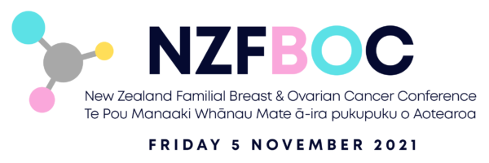

The fully virtual conference to be held
on Friday 5 November 2021.
All sessions will be recorded and available to view 'on-demand' for 90 days after the end of the conference.

It will provide a unique opportunity to bring together for the first time clinicians and experts across this field in Aotearoa, Australia and the UK, to participate in a day of knowledge sharing.
The programme is intended for health professionals however registrations from other interested public and consumers (people impacted by familial breast and ovarian cancer) are also welcome.
To register and for more information see www.nzfboc.org.nz
Kind regards,
NZFBOC Conference, Local Organising Committee

